**Analysis of Bronchoalveolar Lavage Fluid Metatranscriptomes Among Patients with COVID-19 Disease**

Michael Jochum 1, Michael D. Lee 2, Kristen Curry 3, Viktorija Zaksas 4, Elizabeth Vitalis 5, Todd Treangen 3, Kjersti Aagaard 1, Krista Ternus 6

*1Department of Obstetrics and Gynecology, Baylor College of Medicine and Texas Children’s Hospital, Houston, Texas 77030, USA; 2Blue Marble Space Institute of Science, Seattle, Washington 98104, USA; 3Department of Computer Science, Rice University, Houston, TX, 77005, USA; 4Center for Translational Data Science, University of Chicago, Chicago, IL, 60615, USA;* 5Inscripta*, Inc, 5500 Central Ave STE 220, Boulder, CO, 80301, USA; 6Signature Science, LLC, 8329 North Mopac Expressway, Austin TX*

**Abstract:**

To better understand the potential relationship between COVID-19 disease morbidity and microbial community dynamics/functional profiles from a hologenome standpoint, we conducted a multivariate comparison of publicly available human bronchoalveolar lavage fluid (BALF) metatranscriptomes samples amongst COVID-19 (*n*=32), community acquired pneumonia (*n*=25), and uninfected samples (*n*=29). Among our cohort of 86 samples, there were 32 with COVID-19 disease, and 10 of those 32 did not survive. Our overarching hypothesis was that there is a potential informative relationship between the BALF microbiome and the severity of COVID-19 disease onset and progression. After read-filtering and controlling for batch effects, the remaining viral and microbial reads were taxonomically classified, functionally characterized, and analyzed for multivariable associations with COVID-19 morbidity and mortality using linear models. After controlling for differences in publication and study design, we observed significantly unique taxonomic and functional changes to the hologenomes associated with COVID-19**.[WRITE 1 line sentence about ].**  Specifically, taxonomic classifications and functional profiles based on gene ontologies were significantly associated with disease severity, morbidity, and death **[WRITE 1 line sentence about ]** . Collectively, while this data does not speak to causality nor directionality of the association, it does demonstrate a significant relationship between the human microbiome and COVID-19 morbidity and mortality, rendering testable hypotheses that warrant further investigation. **[don’t go over 350 words]**

**Introduction**

**[Write something about sars cov2, why we are looking at the lung, etc] (KT)**

**[Other people have looked at the virus, the host, but only a few have looked at the microbiome andbalf samples both together.] (KT)**

To better understand the potential relationship between COVID-19 morbidity and mortality and the human-microbiome, **[this might be a duplication]** we conducted an analysis using human bronchoalveolar lavage fluid (BALF) metatranscriptome samples sourced from eight publications and nine corresponding public data repositories (Suppl. Tables 1-2). These data arose from BALF specimens from individual subjects grouped into one of three classes: 1) uninfected controls; 2) community acquired pneumonia (CAP) patients; or 3) COVID-19 patients with moderate to severe disease, including death (Table 1). The objectives of the current study were to compare the BALF metatranscriptomes amongst and between each of the three disease cohort classes, and to identify significantly associated taxonomic and functional differences in microbial derived community dynamics. Our overarching testable hypothesis was that there is a potentially informative and discernably significant relationship between the BALF microbiome and the severity of COVID-19 disease.

**Methods**

*Metadata sources.* Publicly available Illumina reads were downloaded from the National Center for Biotechnology Information (NCBI; citation) Sequence Read Archive (SRA) or the China National Center for Bioinformation (CNCB) National Genomics Data Center (NGDC; citation) (Suppl. Tables 1-2), along with the original publications where the clinical information was obtained for downstream analysis of BALF samples (1-8).

*Analyses*. After the raw reads were downloaded from their sources, the quality of the reads was assessed before and after trimming with FastQC (9), and quality control was performed on the downloaded sequence reads with Trimmomatic (10). To control for different sequencing approaches by dataset (e.g., datasets being paired, or single-end reads), all paired-end reads were merged with FLASH (11) and concatenated with unmerged reads into one fastq file per sample. Human and PhiX reads were filtered out with a custom Kraken2 (12) built with solely human and PhiX references, and low-complexity sequences were removed with fastp (13). Taxonomic analysis was subsequently performed with Kraken2 (12) utilizing their standard database. The processed fastq datasets with human and PhiX reads removed were converted to fasta files and analyzed with SeqScreen (14) to obtain a list of leaf-node molecular function and biological process Gene Ontology (GO; citation) terms present within each of the samples. The CoV-IRT-Micro conda package (<https://github.com/AstrobioMike/CoV-IRT-Micro>) was used to propagate parent GO terms, parse SeqScreen outputs by taxonomic domain, and summarize Kraken2 taxonomic results and SeqScreen-reported protein identifiers. SeqScreen matches reads to a reference database of proteins derived from UniProt (citation); in cases where we track a specific GO term to its source proteins, we are referring to investigating what the underlying reference proteins to which our reads mapped. Additional information about the commands and versions of the tools used to process raw reads and assign taxonomies and GO terms can be found online on the OSF project site (<https://osf.io/7nrd3/>).

Parent-propagated GO term counts for all domains other than eukaryotes were imported into a working phyloseq (15) object alongside collected and curated clinical metadata using R 4.03 (16). Sample types of “unknown” and “sick” from Huang *et al*. (7) and Michalovich *et al.* (6) were pruned from subsequent analysis. “Healthy” samples from Michalovich *et al.* (6) and SARS-CoV-2 viral-enriched samples from Shen *et al*. (5) (PRJNA605907) were also pruned from subsequent analysis (Suppl. Tables 1-2). Whenever negative controls were present, the R package decontam (17) was used to identify and remove potential contaminating organisms. After read-filtering and batch-effect sample removal, sample cohorts of n=29 uninfected samples from 29 subjects, n=25 CAP samples from 25 subjects, and n=32 COVID-19 samples from 18 subjects were available for comparison (total, n=86 BALF samples from 72 subjects). Amongst the COVID-19 cohort at the time of the index study publication, n=10 samples were from 5 known-deceased subjects, n=15 samples were from 9 known-survived subjects, and n=7 from 4 subjects of the total 32 COVID-19 samples in this meta-analysis did not have published outcomes. GO term abundances from the remaining subjects’ specimens were compositionally transformed and compared by case type and outcome (COVID-19 only) via MaAsLin2 (18) (min abundance=0.01, min prevalence=0.1, normalization=CLR)~~, controlling for random effects of publication and patient~~, with max significance cutoff of q < 0.05 with Benjamini-Hochberg multiple test correction (19) (Suppl. Table 3). Additionally, GO term counts were square-root transformed and subjected to community typing with Dirichlet Multinomial Mixtures (20) (Suppl. Table 4). Statistically significant GO terms were thereafter ordered by parental lineage and visualized alongside consensus DMM clusters and metadata columns publication, case, and outcome using the package pheatmap (v1.0.12) (21). Heat-tree taxonomic comparisons were visualized using metacoder (22). More detailed information about the statistical analysis process and figure generation can be found online (https://github.com/COV-IRT/microbial ).

**Results**

*Comparison between disease classes (i.e., uninfected controls, or patients with Community Acquired Pneumonia (CAP) or COVID-19 disease)*

After controlling for random effects of publication and patient, results from the MaAsLin2 comparison across individual subjects were grouped by one of three classes: 1) uninfected controls; 2) CAP patients; or 3) COVID-19 patients with moderate to severe disease, including death (Table 1). This revealed 35 out of 13,534 GO terms were associated with patients with COVID-19 when compared to patients with CAP or uninfected control subjects (Figure 1, Table 2, Table 3). Significant GO terms were grouped under seven parental GO terms (depth=1), including catalytic activity [GO:0003824], binding [GO.0005488], metabolic process [GO:0008152], cellular process [GO:0009987], biological regulation [GO:0065007], viral process [GO:0016032], and interspecies interaction between organisms [GO:0044419] (Figure 1, Suppl. Table 3).

GO terms enriched in the COVID-19 cohort compared to the uninfected cohort included hydrolase activity [GO:0016787], as well as all significant GO terms with the parental terms of biological regulation [GO:0065007], viral process [GO:0016032], and interspecies interaction between organisms [GO:0044419]. Hydrolase activity [GO:0016787], nucleic acid metabolic process [GO:0090304], and many GO terms classified under interspecies interaction between organisms [GO:0044419] were also enriched in the COVID-19 cohort when compared to CAP. In contrast, GO terms enriched in the uninfected cohort compared to the COVID-19 cohort included all significant GO terms with the parental terms of cellular process [GO:0009987], metabolic process [GO:0008152], binding [GO.0005488], and terms classified under catalytic activity [GO:0003824] other than hydrolase activity [GO:0016787]. Results from the Dirichlet multinomial mixtures clustering analysis using all 13,534 gene ontology counts resulted in a best model fit using 3 distinct clusters that were significantly associated with each case cohort [p<0.0001] (Figure 1, Suppl. Table 4).

Taxonomic comparisons of the COVID-19 cohort to uninfected and CAP cohorts revealed a statistically significant decrease of several microbial genera within the phylum of Proteobacteria, including those of the families *Sphingomonadaceae* (i.e., *Sphingobium*, *Sphingopyxis*, *Sphingomonas*) and *Rhodobacteraceae* (i.e., *Paracoccus*) (Figure 2, Table 5). This included several species belonging to the genus *Sphingomonas* among BALF specimens from COVID-19 patients when compared to both the uninfected (p<0.0001, q <0.001) and CAP cohorts (p<0.005, q <0.05) (Suppl. Table 5). An analysis of the most common SeqScreen outputs taxonomically classified as *Sphingomonas* in BALF specimens among patients with COVID-19, irrespective of disease outcomes, included GO term assignments of hydrogen peroxide catabolic process [GO:0042744], response to oxidative stress [GO:0006979], catalase activity [GO:0004096], heme binding [GO:0020037], and metal ion binding [GO:0046872].

*Metatranscriptomic comparison of BALF specimens from COVID-19 subjects stratified by disease survival or death*

A stratified analysis amongst COVID-19 subjects’ specimens with known survival outcomes (i.e., of 32 samples, n=10 were known deceased, and n=15 were known survived) was performed via MaAsLin2. After controlling for random effects of patient, we observed 21 unique GO terms which were significantly increased in their association with death or survival from COVID-19 disease (q-value < 0.05), with parental GO terms (depth=1) of metabolic process [GO:0090304], binding [GO.0005488], and catalytic activity [GO:0003824] (Table 4, Figure 3). GO terms with significant q-values (< 0.05) that were terminal in the observed GO term lineage (i.e., as specific as possible within the lineages of our result set), included nucleobase-containing compound biosynthetic process [GO:0034654], organonitrogen compound catabolic process [GO:1901565], pyrimidine-containing compound biosynthetic process [GO:0072528], and DNA recombination [GO:0006310] classified under the parental GO term of metabolic process [GO:0008152]; RNA binding [GO:0003723], magnesium ion binding [GO:0000287], and zinc ion binding [GO:0008270] classified under the parental GO term of binding [GO.0005488]; and oxidoreductase activity [GO:0016491] and endopeptidase activity [GO:0004175] classified under the parental GO term of catalytic activity [GO:0003824] (Suppl. Table 3).

Of the nine terminal GO terms that were significantly different in this analysis (q-value < 0.05), RNA binding [GO:0003723] and oxidoreductase activity [GO:0016491] were the most enriched in samples from individuals that survived COVID-19 (Suppl. Table 3). An analysis of the proteins underlying the SeqScreen GO term assignments showed that RNA binding [GO:0003723] is being driven by an enrichment of 30S and 50S ribosomal proteins from the gram-positive cocci belonging to the genera *Streptococcus*, *Granulicatella*, *Enterococcus*, and *Lactococcus*, all of which were particularly prevalent in the “nCov7” survived COVID-19 patient from the Shen *et al.* study (Suppl. Table 6). The enrichment of the oxidoreductase activity [GO:0016491] term among survived COVID-19 patients was driven by many different samples and a variety of bacteria, including those from gram-positive bacteria belonging to the genera *Enterococcus*, *Streptococcus*, *Streptomyces*, *Pediococcus*, *Lactococcus*, and *Granulicatella*. Examples of underlying reference proteins to which reads mapped resulting in our observed oxidoreductase activity [GO:0016491] term included quinone oxidoreductase, pyruvate dehydrogenase, glyceraldehyde-3-phosphate dehydrogenase, and glyceraldehyde-3-phosphate dehydrogenase (Suppl. Table 6). Among the deceased COVID-19 patients, the terminal GO terms of endopeptidase activity [GO:0004175], zinc ion binding [GO:0008270], and nucleobase-containing compound biosynthetic process [GO:0034654] were being driven by an enrichment of SARS-CoV-2 proteins. Mixed among proteins from other organisms, an enrichment of *Variovorax* proteins tagged with the terminal GO terms of pyrimidine-containing compound biosynthetic process [GO:0072528] (e.g., CTP synthase, putative sulfonate/nitrate transport system substrate-binding protein), organonitrogen compound catabolic process [GO:1901565] (e.g., histidine ammonia-lyase, aspartate/glutamate leucyltransferase), magnesium ion binding [GO:0000287] (e.g., phosphoribosyl-AMP cyclohydrolase, phosphopantetheinyl transferase), and DNA recombination [GO:0006310] (e.g., inclusive of possible *Variovorax* phage proteins - integrase family protein, putative transposase IS4 family, phage integrase family protein) appeared in the COVID-19 deceased patients. This enrichment of *Variovorax* proteins among samples from individuals who died of COVID-19 is consistent with the results from the taxonomic comparison analysis, which revealed a statistically significant increase of the family *Comamonadaceae*, belonging to the genus *Variovorax*, and decreases in the family *Bacteriodales* when comparing the deceased to the survived (p<0.0001, q <0.001) (Figure 4) (Suppl Table 5).

**Discussion**

We observed significantly unique discriminant taxonomic and functional features in bronchoalveolar lavage fluid (BALF) metatranscriptomes in association with COVID-19 disease and its mortality. Of note, due to limitations in the depth of clinical metadata by subject, we could not distinguish between COVID-19 pathophysiology or associated medical comorbidities, treatments, nor interventions. However, because of the time interval in which COVID-19 patient specimens were recruited to their respective index studies at the beginning of the outbreak in Wuhan, China (i.e., 2019 and early 2020), COVID-19-specific interventions and treatments had yet to be introduced and thus comparisons between CAP and COVID-19 subject specimens would be less likely to be related to disease-focused therapy.

At the time of this study, the standard Kraken2 taxonomic database included the SARS-CoV-2 reference genome, but the SARS-CoV-2 proteins were not yet added to the SeqScreen database that was used for the functional analysis. This functional analysis demonstrated how GO terms and their corresponding proteins can be used to characterize an emerging pathogen (i.e., a pathogen that is not present in the reference database), as well as significant host microbiome functional shifts. SARS-CoV-2 reads were successfully detected in the taxonomic analysis of COVID-19 BALF samples, and GO terms associated with coronavirus proteins were found to be significantly different in the functional analysis. A number of coronavirus proteins were driving the significant associations of GO terms between COVID-19 and uninfected samples, including modulation by symbiont of host cellular process [GO:0044068], modulation by virus of host cellular process [GO:0019054], modulation by virus of host process [GO:0019048], modulation of process of other organism involved in symbiotic interaction [GO:0051817], modulation by symbiont of host process [GO:0044003], interaction with host [GO:0016032], viral process [GO:0051701], interspecies interaction between organisms [GO:0044419], modulation by symbiont of host cellular process [GO:0044068], and modulation by virus of host cellular process [GO:0019054] (Suppl Table 5). Coronavirus proteins were also driving notable GO term associations in COVID-19 deceased vs. survived, including transition metal ion binding [GO:0046914], zinc ion binding [GO:0008270], organic cyclic compound binding [GO:0097159], endopeptidase activity [GO:0004175], and nucleobase containing compound biosynthetic process [GO:0034654]. While samples from both COVID-19 deceased and survived individuals contained taxonomically and functionally classified coronavirus reads, the significant terminal GO terms of endopeptidase activity [GO:0004175], zinc ion binding [GO:0008270], and nucleobase-containing compound biosynthetic process [GO:0034654] were positively correlated with COVID-19 deceased patients. This was likely due to multiple highly expressed coronavirus proteins being tagged with these GO terms (e.g., replicase polyprotein 1ab, 2'-O-methyltransferase), and a higher SARS-CoV-2 viral load and mRNA expression being present in patients who died of COVID-19 disease.

Distinct taxonomic features of BALF specimens from the COVID-19 vs. uninfected vs. CAP analysis included an increase in the genus *Sphingomonas,* belonging to the *Sphingomonadacae* family,among COVID-19 patients. Notable taxonomic features among COVID-19 patients with mortal disease included increases in log2 median ratios of the genus *Variovorax,* belonging to the *Comamonadaceae* family, and decreases in the class Bacteroidia*,* belonging to the order Bacteroidales. These findings support previous reports regarding an association with *Sphingomonas* (23-26), which is a common opportunistic pathogen found in nosocomial infections. Among the COVID-19 cohort, one of the most highly expressed *Sphingomonas* genes was catalase [UniProt ID = J8VPL9]. This *Sphingomonas* catalase protein is assigned GO terms including hydrogen peroxide catabolic process [GO:0042744], response to oxidative stress [GO:0006979], catalase activity [GO:0004096], heme binding [GO:0020037], and metal ion binding [GO:0046872], and it is responsible for decomposing hydrogen peroxide into water and oxygen. This serves to protect cells from the toxic effects of hydrogen peroxide, which may suggest that *Sphingomonas* spp. respond to COVID-19 conditions in the patient by expressing genes that help them to survive well in environments undergoing great amounts of oxidative stress. Our findings additionally support a previous unpublished report regarding an increase in the abundance of *Variovorax* in COVID-19 patient BALF tissue (27). *Variovorax* spp. have previously been reported in the microbiota of patients with lung cancer (28) and were shown to be a key driver of clustering amongst patients challenged with H1N1 influenza infections (29). The most abundantly expressed *Variovorax* proteins inthe COVID-19 cohort included those involved in cell wall organization and the plasma membrane (e.g., binding-protein-dependent transport systems inner membrane component [UniProt ID = E6VB76], endolytic peptidoglycan transglycosylase RlpA [UniProt ID = T1XG48]), oxidoreductase activity (e.g., methylenetetrahydrofolate reductase [UniProt IDs = J2L4W7, T1XH55], taurine dioxygenase [UniProt ID = T1XBI4], NADH-quinone oxidoreductase subunit H [UniProt ID = E6V509]), hydrolase activity (e.g., N-acyl-D-aspartate/D-glutamate deacylase [UniProt ID = J2T0U3], cytokinin riboside 5'-monophosphate phosphoribohydrolase [UniProt IDs = E6V0P4, J3CLH3]), and ATP-binding transport (e.g., ABC transporter related protein [UniProt ID = E6UUY9], extracellular solute-binding protein family 5 [UniProt ID = E6V3F7]).

**Conclusions**

Here we identified significant taxonomic and functional differences in BALF metatranscriptomes associated with COVID-19 disease and death. By the nature of this analysis, this work does not address causality or directionality. But it does identify a relationship between the human microbiome and COVID-19 morbidity and mortality, and the specific functions and taxa identified warrant further investigation.

**Acknowledgments**

We would like to thank the COVIRT microbial subgroup team members and give special acknowledgment to John Fonner and the Texas Advanced Computing Center (TACC) at The University of Texas at Austin for providing HPC resources that have contributed to the research results reported.

**References**

1. Chen L, Liu W, Zhang Q, Xu K, Ye G, Wu W, et al. RNA based mNGS approach identifies a novel human coronavirus from two individual pneumonia cases in 2019 Wuhan outbreak. Emerg Microbes Infect. 2020;9: 313–319.

2. Wu F, Zhao S, Yu B, Chen Y-M, Wang W, Song Z-G, et al. A new coronavirus associated with human respiratory disease in China. Nature. 2020;579: 265–269.

3. Zhou P, Yang X-L, Wang X-G, Hu B, Zhang L, Zhang W, et al. A pneumonia outbreak associated with a new coronavirus of probable bat origin. Nature. 2020;579: 270–273.

4. Xiong Y, Liu Y, Cao L, Wang D, Guo M, Jiang A, et al. Transcriptomic characteristics of bronchoalveolar lavage fluid and peripheral blood mononuclear cells in COVID-19 patients. Emerg Microbes Infect. 2020;9: 761–770.

5. Shen Z, Xiao Y, Kang L, Ma W, Shi L, Zhang L, et al. Genomic Diversity of Severe Acute Respiratory Syndrome–Coronavirus 2 in Patients with Coronavirus Disease 2019. Clinical Infectious Diseases. 2020. Doi:10.1093/cid/ciaa203

6. Michalovich D, Rodriguez-Perez N, Smolinska S, Pirozynski M, Mayhew D, Uddin S, et al. Obesity and disease severity magnify disturbed microbiome-immune interactions in asthma patients. Nat Commun. 2019;10: 5711.

7. Huang W, Yin C, Wang G, Rosenblum J, Krishnan S, Dimitrova N, et al. Optimizing a Metatranscriptomic Next-Generation Sequencing Protocol for Bronchoalveolar Lavage Diagnostics. J Mol Diagn. 2019;21: 251–261.

8. Ren L, Zhang R, Rao J, Xiao Y, Zhang Z, Yang B, et al. Transcriptionally Active Lung Microbiome and Its Association with Bacterial Biomass and Host Inflammatory Status. mSystems. 2018;3. Doi:10.1128/mSystems.00199-18

9. Andrews S. FastQC: A Quality Control Tool for High Throughput Sequence Data. Available online at: http://www.bioinformatics.babraham.ac.uk/projects/fastqc/ (2015).

10. Bolger AM, Lohse M, Usadel B. Trimmomatic: a flexible trimmer for Illumina sequence data. Bioinformatics. 2014. pp. 2114–2120. doi:10.1093/bioinformatics/btu170

11. Magoč T, Salzberg SL. FLASH: fast length adjustment of short reads to improve genome assemblies. Bioinformatics. 2011;27: 2957–2963.

12. Wood DE, Lu J, Langmead B. Improved metagenomic analysis with Kraken 2. Genome Biol. 2019;20: 1–13.

13. Chen S, Zhou Y, Chen Y, Gu J. fastp: an ultra-fast all-in-one FASTQ preprocessor. Bioinformatics. 2018;34: i884–i890.

14. Balaji A, Kille B, Kappell AD, Godbold GD, Diep M, Leo Elworth RA, et al. SeqScreen: Accurate and Sensitive Functional Screening of Pathogenic Sequences via Ensemble Learning. bioRxiv. 2021. p. 2021.05.02.442344. doi:10.1101/2021.05.02.442344

15. McMurdie PJ, Holmes S. phyloseq: An R Package for Reproducible Interactive Analysis and Graphics of Microbiome Census Data. PLoS One. 2013;8: e61217.

16. R Core Team. R: A language and environment for statistical computing. R Foundation for Statistical Computing, Vienna, Austria. 2021. URL: https://www.R-project.org/

17. Davis NM, Proctor DM, Holmes SP, Relman DA, Callahan BJ. Simple statistical identification and removal of contaminant sequences in marker-gene and metagenomics data. Microbiome. 2018;6: 1–14.

18. Mallick H, Rahnavard A, McIver LJ, Ma S, Zhang Y, Nguyen LH, et al. Multivariable Association Discovery in Population-scale Meta-omics Studies. bioRxiv. 2021. p. 2021.01.20.427420. doi:10.1101/2021.01.20.427420

19. Benjamini Y, Hochberg Y. Controlling the false discovery rate: a practical and powerful

approach to multiple testing. Journal of the Royal statistical society: series B (Methodological).

1995;57(1):289-300.

20. Holmes I, Harris K, Quince C. Dirichlet multinomial mixtures: generative models for microbial metagenomics. PLoS One. 2012;7: e30126.

21. Kolde R. pheatmap: Pretty heatmaps. 2015. https://CRAN.Rproject.org/package=pheatmap

22. Foster ZSL, Sharpton TJ, Grünwald NJ. Metacoder: An R package for visualization and manipulation of community taxonomic diversity data. PLoS Comput Biol. 2017;13: e1005404.

23. Sirivongrangson P, Kulvichit W, Payungporn S, Pisitkun T, Chindamporn A, Peerapornratana S, et al. Endotoxemia and circulating bacteriome in severe COVID-19 patients. Intensive Care Med Exp. 2020;8: 72.

24. Chen S, Zhu Q, Xiao Y, Wu C, Jiang Z, Liu L, et al. Clinical and etiological analysis of co-infections and secondary infections in COVID-19 patients: An observational study. Clin Respir J. 2021;15: 815–825.

25. Ryan MP, Adley CC. Sphingomonas paucimobilis: a persistent Gram-negative nosocomial infectious organism. J Hosp Infect. 2010;75: 153–157.

26. Hsueh PR, Teng LJ, Yang PC, Chen YC, Pan HJ, Ho SW, et al. Nosocomial infections caused by Sphingomonas paucimobilis: clinical features and microbiological characteristics. Clin Infect Dis. 1998;26: 676–681.

27. Han Y, Jia Z, Shi J, Wang W, He K. The active lung microbiota landscape of COVID-19 patients. medRxiv. 2020; 2020.08.20.20144014.

28. Rose UD, Vetizou M, Roy S, Edwards B, Peck M, Smith L, et al. Role of the Microbiota in Primary Lung Cancer Initiation and Progression. The Journal of Immunology. 2019;202: 190.1–190.1.

29. Chaban B, Albert A, Links MG, Gardy J, Tang P, Hill JE. Characterization of the upper respiratory tract microbiomes of patients with pandemic H1N1 influenza. PLoS One. 2013;8. doi:10.1371/journal.pone.0069559

Table 1. Overview of Meta-analysis Dataset Clinical Characteristics (*n*=86)

|  |  |  |  |
| --- | --- | --- | --- |
| **Variable** | Uninfected | Community Acquired Pneumonia | COVID-19 |
| **Cohort** | 29 (33.72%) | 25 (29.07%) | 32(37.21%) |
| **Outcome  (COVID-19 only)** |  |  |  |
| Deceased | - | - | 10 (31.25%) |
| Survived | - | - | 15 (46.87%) |
| Unspecified | - | - | 7 (21.88%) |
| **Sex** |  |  |  |
| female | 4 (18.18%) | 8 (36.36%) | 10 (45.45%) |
| male | 5 (13.15%) | 11 (28.94%) | 22 (57.89%) |
| unspecified | 20 (76.92%) | 6(23.07%) | 0 (0%) |
| **Reads** |  |  |  |
| paired | 29 (37.18%) | 25 (32.05%) | 24 (30.77%) |
| single | 0 (0%) | 0 (0%) | 8 (100%) |
| **Publication** |  |  |  |
| Chen | 0 (0%) | 0 (0%) | 2 (100%) |
| Ren | 9 (100%) | 0 (0%) | 0 (0%) |
| Shen | 20 (32.79%) | 25 (40.98%) | 16 (40.98%) |
| Wu | 0 (0%) | 0 (0%) | 1 (100%) |
| Xiong | 0 (0%) | 0 (0%) | 4 (100%) |
| Zhou | 0 (0%) | 0 (0%) | 9 (100%) |
| **Numeric variables (**mean ± SD) |  |  |  |
| Age | 53.2 ± 13.3 (n=9) | 51.2 ± 19.8 (n=17) | 47.3 ± 11.5 (n=32) |
| Temp. °C | - | 38.4 ± 0.91 (n=15) | 38.4 ± 0.715 (n=8) |
| days after onset | - | 9.07 ± 3.17 (n=14) | 12.05 ± 6.5 (n=41) |

Table 2. MaAsLin2-Derived Significant Gene Ontologies Associated with COVID-19 (n=32) when Compared to the Community Acquired Pneumonia (n=25) Cohort. Comparisons were conducted using compositional transformed and CLR normalized count matrices, controlled for the random effects of publication and patient, and adjusted for multiple test comparisons using the Benajmini Hochberg correction method.

|  |  |  |  |  |  |  |  |  |
| --- | --- | --- | --- | --- | --- | --- | --- | --- |
| feature | namespace | value (vs COVID-19) | coef | stderr | N | N.not.0 | pval | qval |
| hydrolase activity | GO:0016787 | Community Acquired Pneumonia | -0.008 | 0.001 | 86.000 | 69.000 | 0.000 | 0.000 |
| cellular process | GO:0009987 | Community Acquired Pneumonia | 0.010 | 0.002 | 86.000 | 74.000 | 0.000 | 0.000 |
| transferase activity | GO:0016740 | Community Acquired Pneumonia | 0.006 | 0.002 | 86.000 | 58.000 | 0.000 | 0.001 |
| modulation by virus of host cellular process | GO:0019054 | Community Acquired Pneumonia | -0.004 | 0.001 | 86.000 | 11.000 | 0.000 | 0.001 |
| modulation by symbiont of host cellular process | GO:0044068 | Community Acquired Pneumonia | -0.004 | 0.001 | 86.000 | 11.000 | 0.000 | 0.001 |
| biosynthetic process | GO:0009058 | Community Acquired Pneumonia | 0.005 | 0.001 | 86.000 | 23.000 | 0.000 | 0.001 |
| cellular macromolecule metabolic process | GO:0044260 | Community Acquired Pneumonia | 0.002 | 0.001 | 86.000 | 4.000 | 0.001 | 0.003 |
| organic substance biosynthetic process | GO1901576 | Community Acquired Pneumonia | 0.003 | 0.001 | 86.000 | 12.000 | 0.001 | 0.004 |
| cellular biosynthetic process | GO:0044249 | Community Acquired Pneumonia | 0.003 | 0.001 | 86.000 | 12.000 | 0.001 | 0.004 |
| transferase activity transferring phosphorus containing groups | GO:0016772 | Community Acquired Pneumonia | 0.005 | 0.001 | 86.000 | 14.000 | 0.001 | 0.004 |
| cellular metabolic process | GO:0044237 | Community Acquired Pneumonia | 0.004 | 0.001 | 86.000 | 72.000 | 0.005 | 0.012 |
| modulation by virus of host process | GO:0019048 | Community Acquired Pneumonia | -0.004 | 0.001 | 86.000 | 18.000 | 0.005 | 0.012 |
| nucleotidyltransferase activity | GO:0016779 | Community Acquired Pneumonia | 0.003 | 0.001 | 86.000 | 7.000 | 0.006 | 0.012 |
| metabolic process | GO:0008152 | Community Acquired Pneumonia | 0.005 | 0.002 | 86.000 | 76.000 | 0.006 | 0.013 |
| organonitrogen compound metabolic process | GO:1901564 | Community Acquired Pneumonia | 0.002 | 0.001 | 86.000 | 5.000 | 0.009 | 0.018 |
| modulation by symbiont of host process | GO:0044003 | Community Acquired Pneumonia | -0.003 | 0.001 | 86.000 | 18.000 | 0.018 | 0.032 |
| modulation of process of other organism involved in symbiotic interaction | GO:0051817 | Community Acquired Pneumonia | -0.003 | 0.001 | 86.000 | 18.000 | 0.018 | 0.032 |
| modulation of process of other organism | GO:0035821 | Community Acquired Pneumonia | -0.003 | 0.001 | 86.000 | 18.000 | 0.018 | 0.032 |
| organic substance metabolic process | GO:0071704 | Community Acquired Pneumonia | 0.003 | 0.001 | 86.000 | 76.000 | 0.026 | 0.045 |
| nucleic acid metabolic process | GO:0090304 | Community Acquired Pneumonia | -0.002 | 0.001 | 86.000 | 17.000 | 0.029 | 0.048 |

Table 3. MaAsLin2-Derived Significant Gene Ontologies Associated with COVID-19 (n=32) when Compared to the Uninfected (n=29) Cohort. Comparisons were conducted using compositional transformed and CLR normalized count matrices, controlled for the random effects of publication and patient, and adjusted for multiple test comparisons using the Benjamini Hochberg correction method.

|  |  |  |  |  |  |  |  |  |
| --- | --- | --- | --- | --- | --- | --- | --- | --- |
| feature | namespace | value (vs COVID-19) | coef | stderr | N | N.not.0 | pval | qval |
| cellular process | GO:0009987 | Uninfected | 0.016 | 0.002 | 86.000 | 74.000 | 0.000 | 0.000 |
| metabolic process | GO:0008152 | Uninfected | 0.013 | 0.002 | 86.000 | 76.000 | 0.000 | 0.000 |
| modulation by symbiont of host cellular process | GO:0044068 | Uninfected | -0.007 | 0.001 | 86.000 | 11.000 | 0.000 | 0.000 |
| modulation by virus of host cellular process | GO:0019054 | Uninfected | -0.007 | 0.001 | 86.000 | 11.000 | 0.000 | 0.000 |
| modulation by virus of host process | GO:0019048 | Uninfected | -0.008 | 0.001 | 86.000 | 18.000 | 0.000 | 0.000 |
| organic substance metabolic process | GO:0071704 | Uninfected | 0.008 | 0.001 | 86.000 | 76.000 | 0.000 | 0.000 |
| cellular macromolecule metabolic process | GO:0044260 | Uninfected | 0.004 | 0.001 | 86.000 | 4.000 | 0.000 | 0.000 |
| cellular metabolic process | GO:0044237 | Uninfected | 0.009 | 0.001 | 86.000 | 72.000 | 0.000 | 0.000 |
| modulation by symbiont of host process | GO:0044003 | Uninfected | -0.008 | 0.001 | 86.000 | 18.000 | 0.000 | 0.000 |
| modulation of process of other organism | GO:0035821 | Uninfected | -0.008 | 0.001 | 86.000 | 18.000 | 0.000 | 0.000 |
| modulation of process of other organism involved in symbiotic interaction | GO:0051817 | Uninfected | -0.008 | 0.001 | 86.000 | 18.000 | 0.000 | 0.000 |
| hydrolase activity | GO:0016787 | Uninfected | -0.008 | 0.001 | 86.000 | 69.000 | 0.000 | 0.000 |
| interaction with host | GO:0051701 | Uninfected | -0.009 | 0.002 | 86.000 | 20.000 | 0.000 | 0.000 |
| viral process | GO:0016032 | Uninfected | -0.013 | 0.002 | 86.000 | 31.000 | 0.000 | 0.000 |
| transferase activity | GO:0016740 | Uninfected | 0.009 | 0.002 | 86.000 | 58.000 | 0.000 | 0.000 |
| primary metabolic process | GO:0044238 | Uninfected | 0.006 | 0.001 | 86.000 | 74.000 | 0.000 | 0.000 |
| symbiotic process | GO:0044403 | Uninfected | -0.014 | 0.002 | 86.000 | 31.000 | 0.000 | 0.000 |
| interspecies interaction between organisms | GO:0044419 | Uninfected | -0.014 | 0.002 | 86.000 | 31.000 | 0.000 | 0.000 |
| macromolecule metabolic process | GO:0043170 | Uninfected | 0.004 | 0.001 | 86.000 | 66.000 | 0.000 | 0.000 |
| organonitrogen compound metabolic process | GO:1901564 | Uninfected | 0.004 | 0.001 | 86.000 | 5.000 | 0.000 | 0.000 |
| binding | GO:0005488 | Uninfected | 0.004 | 0.001 | 86.000 | 81.000 | 0.000 | 0.001 |
| nitrogen compound metabolic process | GO:0006807 | Uninfected | 0.004 | 0.001 | 86.000 | 70.000 | 0.000 | 0.001 |
| biosynthetic process | GO:0009058 | Uninfected | 0.004 | 0.001 | 86.000 | 23.000 | 0.005 | 0.012 |
| ion binding | GO:0043167 | Uninfected | 0.002 | 0.001 | 86.000 | 8.000 | 0.006 | 0.012 |
| regulation of biological process | GO:0050789 | Uninfected | -0.003 | 0.001 | 86.000 | 15.000 | 0.010 | 0.020 |
| cellular nitrogen compound metabolic process | GO:0034641 | Uninfected | 0.002 | 0.001 | 86.000 | 53.000 | 0.011 | 0.021 |
| transferase activity transferring phosphorus containing groups | GO:0016772 | Uninfected | 0.004 | 0.001 | 86.000 | 14.000 | 0.014 | 0.027 |
| catalytic activity | GO:0003824 | Uninfected | 0.009 | 0.004 | 86.000 | 86.000 | 0.023 | 0.041 |
| RNA metabolic process | GO:0016070 | Uninfected | 0.002 | 0.001 | 86.000 | 6.000 | 0.028 | 0.048 |
| regulation of cellular process | GO:0050794 | Uninfected | -0.002 | 0.001 | 86.000 | 12.000 | 0.030 | 0.050 |

Table 4. MaAsLin2-Derived Significant Gene Ontologies Associated with COVID-19 Disease Outcome (Deceased vs. Survived). Comparisons were conducted using compositional transformed and CLR normalized count matrices, controlled for the random effect of patient ID, and adjusted for multiple test comparisons using the Benajmini Hochberg correction method.

|  |  |  |  |  |  |  |  |  |  |
| --- | --- | --- | --- | --- | --- | --- | --- | --- | --- |
| name | ontology | namespace | depth | coef | stderr | pval | qval | N | N.not.zero |
| pyrimidine-containing compound metabolic process | biological_process | GO:0072527 | 4 | -4.815 | 0.867 | <0.001 | <0.001 | 25 | 12 |
| nucleobase-containing compound biosynthetic process | biological_process | GO:0034654 | 5 | -0.630 | 0.117 | <0.001 | <0.001 | 25 | 25 |
| transition metal ion binding | molecular_function | GO:0046914 | 5 | -0.545 | 0.106 | <0.001 | <0.001 | 25 | 25 |
| aromatic compound biosynthetic process | biological_process | GO:0019438 | 4 | -0.478 | 0.116 | <0.001 | 0.004 | 25 | 25 |
| heterocycle biosynthetic process | biological_process | GO:0018130 | 4 | -0.393 | 0.100 | <0.001 | 0.007 | 25 | 25 |
| macromolecule biosynthetic process | biological_process | GO:0009059 | 4 | 0.382 | 0.103 | <0.001 | 0.015 | 25 | 25 |
| RNA metabolic process | biological_process | GO:0016070 | 6 | -0.310 | 0.086 | <0.001 | 0.018 | 25 | 25 |
| RNA phosphodiester bond hydrolysis | biological_process | GO:0090501 | 7 | -1.412 | 0.402 | <0.001 | 0.024 | 25 | 17 |
| magnesium ion binding | molecular_function | GO:0000287 | 5 | -2.336 | 0.709 | 0.001 | 0.036 | 25 | 11 |
| RNA binding | molecular_function | GO:0003723 | 4 | 0.989 | 0.303 | 0.001 | 0.036 | 25 | 23 |
| zinc ion binding | molecular_function | GO:0008270 | 6 | -0.880 | 0.266 | 0.001 | 0.036 | 25 | 24 |
| phosphorylation | biological_process | GO:0016310 | 5 | 2.897 | 0.888 | 0.001 | 0.036 | 25 | 13 |
| organonitrogen compound catabolic process | biological_process | GO:1901565 | 4 | -2.388 | 0.721 | 0.001 | 0.036 | 25 | 12 |
| endopeptidase activity | molecular_function | GO:0004175 | 4 | -0.995 | 0.309 | 0.001 | 0.037 | 25 | 21 |
| pyrimidine-containing compound biosynthetic process | biological_process | GO:0072528 | 5 | -5.505 | 1.711 | 0.001 | 0.037 | 25 | 7 |
| DNA recombination | biological_process | GO:0006310 | 7 | -2.130 | 0.667 | 0.001 | 0.037 | 25 | 12 |
| oxidoreductase activity | molecular_function | GO:0016491 | 2 | 2.541 | 0.801 | 0.002 | 0.037 | 25 | 13 |
| carbohydrate metabolic process | biological_process | GO:0005975 | 3 | 2.245 | 0.717 | 0.002 | 0.039 | 25 | 15 |
| catalytic activity, acting on RNA | molecular_function | GO:0140098 | 2 | -0.546 | 0.174 | 0.002 | 0.039 | 25 | 25 |
| pyrophosphatase activity | molecular_function | GO:0016462 | 5 | -0.326 | 0.107 | 0.002 | 0.048 | 25 | 25 |
| organic cyclic compound binding | molecular_function | GO:0097159 | 2 | 0.443 | 0.145 | 0.002 | 0.048 | 25 | 25 |
| hydrolase activity, acting on acid anhydrides | molecular_function | GO:0016817 | 3 | -0.323 | 0.107 | 0.003 | 0.052 | 25 | 25 |

Table 5. Log2 Median Ratio values of Top Taxa Associated with COVID-19 (n= 29) Compared to Community Acquired Pneumonia (n=25) and Uninfected (n=32) Cohorts. Values depicted in the table are mean values at the genus level for taxa that containing >10 species level significant comparisons with a qvalue < 0.05 and a log2 median ratio >1.0 using Wilcoxon rank sum test adjusted for multiple test comparison. A full list of significant taxonomic comparison values at the species level (when applicable) can be found in Supplementary Table 5.

|  |  |  |  |  |  |  |  |
| --- | --- | --- | --- | --- | --- | --- | --- |
| treatment 1 | treatment 2 | log2 median ratio | median diff | mean diff | p value | q value | taxon name |
| COVID-19 | Community acquired pneumonia | -2.0539 | -0.0728 | -0.1332 | 0.0067 | 0.0224 | *Paracoccus* |
| COVID-19 | Community acquired pneumonia | -2.0539 | -0.0728 | -0.1332 | 0.0067 | 0.0224 | *Sphingobium* |
| COVID-19 | Community acquired pneumonia | -2.0539 | -0.0728 | -0.1332 | 0.0067 | 0.0224 | *Sphingopyxis* |
| COVID-19 | Community acquired pneumonia | -2.0539 | -0.0728 | -0.1332 | 0.0067 | 0.0224 | *Sphingomonas* |
| COVID-19 | Uninfected | -4.3829 | -0.4587 | -0.3767 | 0.0000 | 0.0000 | *Paracoccus* |
| COVID-19 | Uninfected | -4.3829 | -0.4587 | -0.3767 | 0.0000 | 0.0000 | *Sphingobium* |
| COVID-19 | Uninfected | -4.3829 | -0.4587 | -0.3767 | 0.0000 | 0.0000 | *Sphingopyxis* |
| COVID-19 | Uninfected | -4.3829 | -0.4587 | -0.3767 | 0.0000 | 0.0000 | *Sphingomonas* |
| COVID-19 | Uninfected | -5.1294 | -0.4164 | -0.3356 | 0.0000 | 0.0000 | *Bradyrhizobium* |
| COVID-19 | Uninfected | -5.1294 | -0.4164 | -0.3356 | 0.0000 | 0.0000 | *Methylobacterium* |

Table 6. Log2 Median Ratio Counts of Taxa Associated with COVID-19 Mortality when Comparing Deceased (n=10) versus Survived (n=15). Comparisons were conducted using Wilcoxon rank sum test and adjusted for multiple test comparisons using the Benjamini Hochberg correction method.

|  |  |  |  |  |  |
| --- | --- | --- | --- | --- | --- |
| log2 median ratio | Median diff | Mean diff | p value | q value | Taxonomy |
| 2.25 | 0.361 | 0.371 | 0.00017 | 0.00691 | *Comamonadaceae* |
| 5.21 | 0.405 | 0.377 | 0.00017 | 0.00691 | *Variovorax* |
| 2.97 | 0.002 | 0.002 | 0.00353 | 0.074 | *Vibrionales* |
| 2.97 | 0.002 | 0.002 | 0.00353 | 0.074 | *Vibrionaceae* |
| 3.8 | 0.002 | 0.00181 | 0.00492 | 0.0827 | *Vibrio* |
| 1.84 | 0.0549 | 0.13 | 0.0137 | 0.124 | *Bacilli* |
| 2.24 | 0.403 | 0.297 | 0.0163 | 0.124 | *Burkholderiales* |
| 3.16 | 0.002 | 0.002 | 0.0157 | 0.124 | *Alteromonadales* |
| 3.61 | 0.004 | 0.004 | 0.0156 | 0.124 | *Yersiniaceae* |
| 2.1 | 0.005 | 0.00435 | 0.0156 | 0.124 | *Salmonella* |
| 1.77 | 0.011 | 0.064 | 0.0475 | 0.274 | *Streptococcaceae* |
| 2.29 | 0.425 | 0.296 | 0.0264 | 0.185 | *Betaproteobacteria* |
| -5.13 | -0.103 | -0.104 | 0.0308 | 0.199 | *Bacteroidia* |
| -5.18 | -0.099 | -0.102 | 0.00962 | 0.124 | *Bacteroidales* |

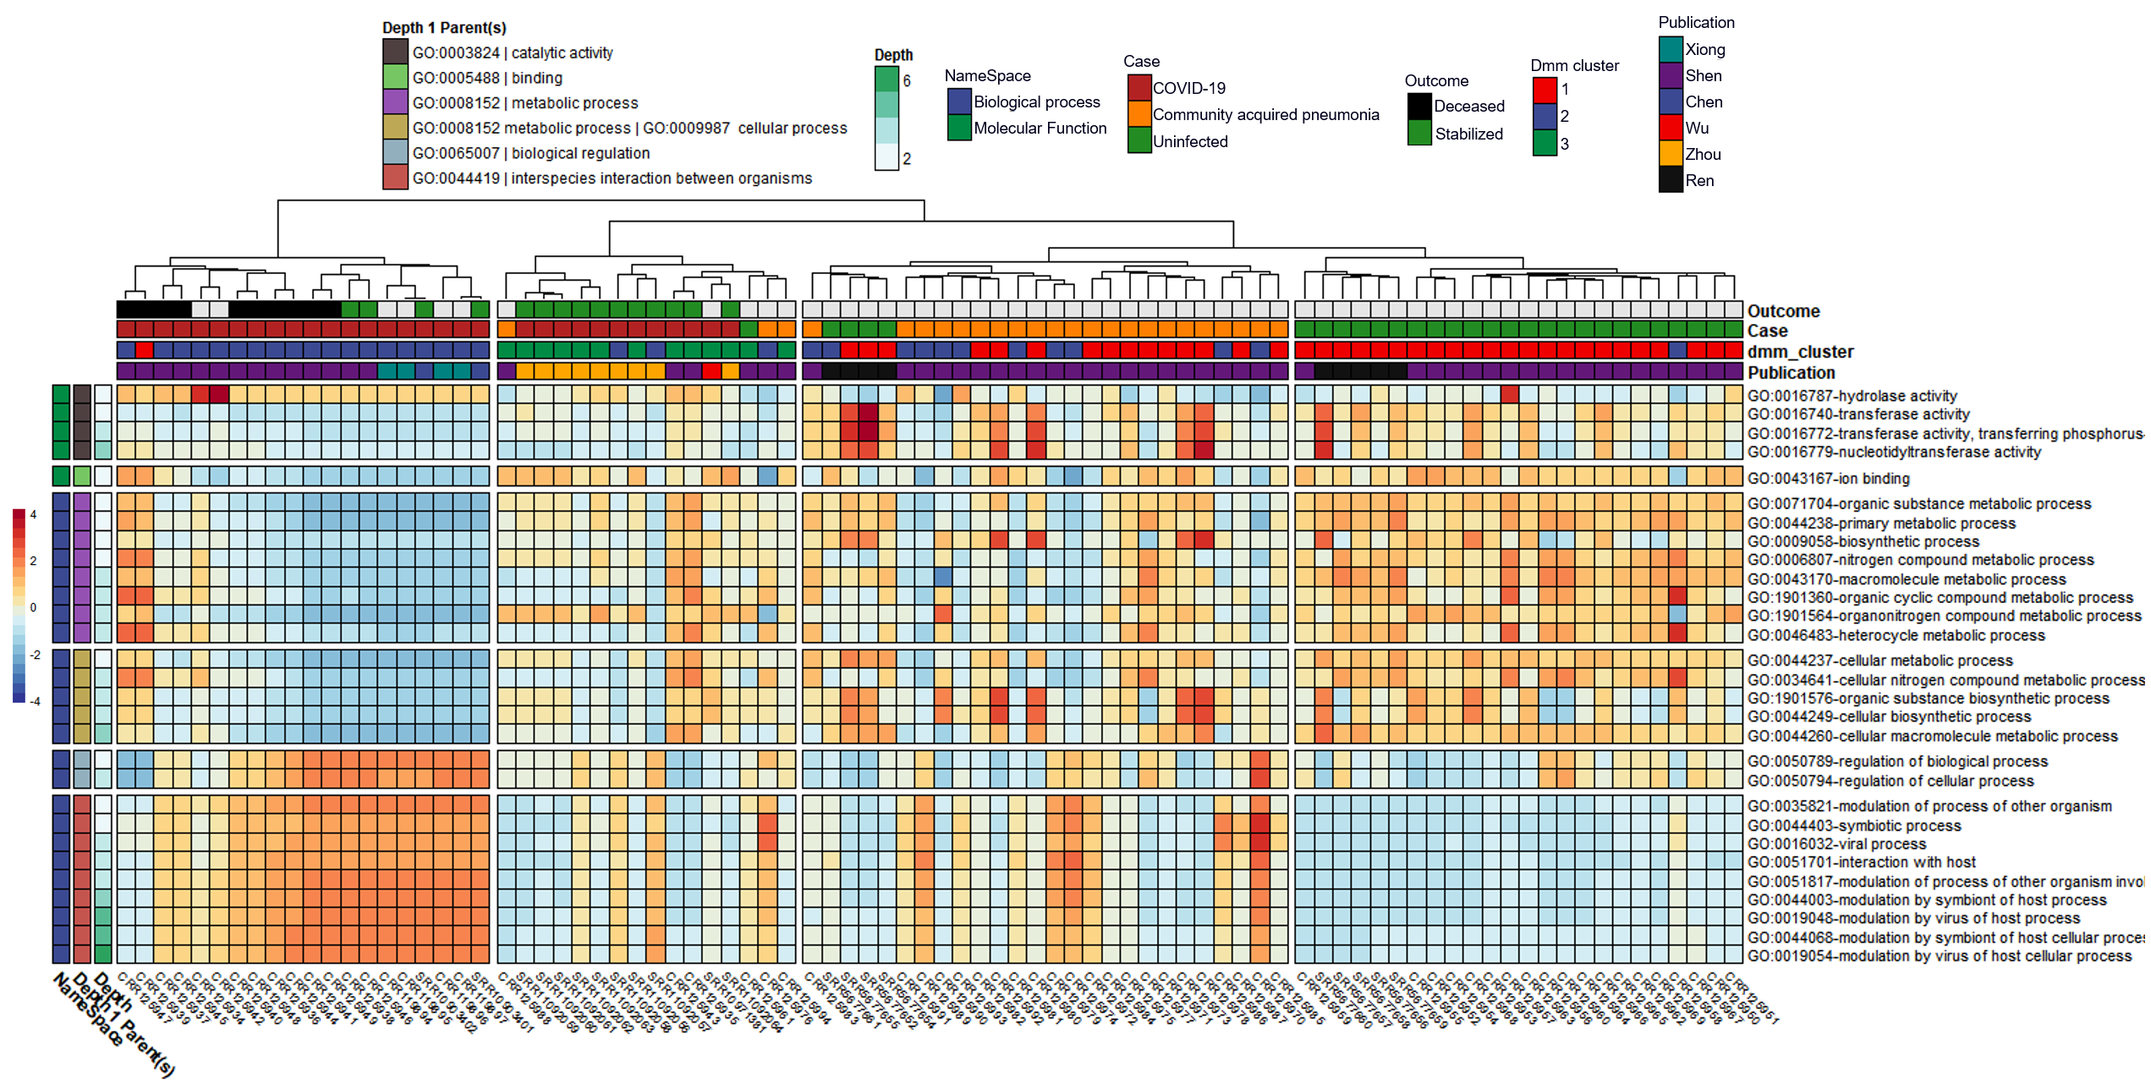

Figure 1. Heatmap with Notable Microbially-Derived Gene Ontology Functional Annotations Associated with COVID-19 (n=32), as Compared to Community Acquired Pneumonia (n=29) & Uninfected (n=25) Cohorts. Rows are sorted by parental GO terms (depth=1), and columns are clustered by Euclidean distance using ward D2 clustering. Comparisons were conducted using MaAsLin2, controlling for publication and patient ID with Benjamini Hochberg multiple test comparison (q<0.05).

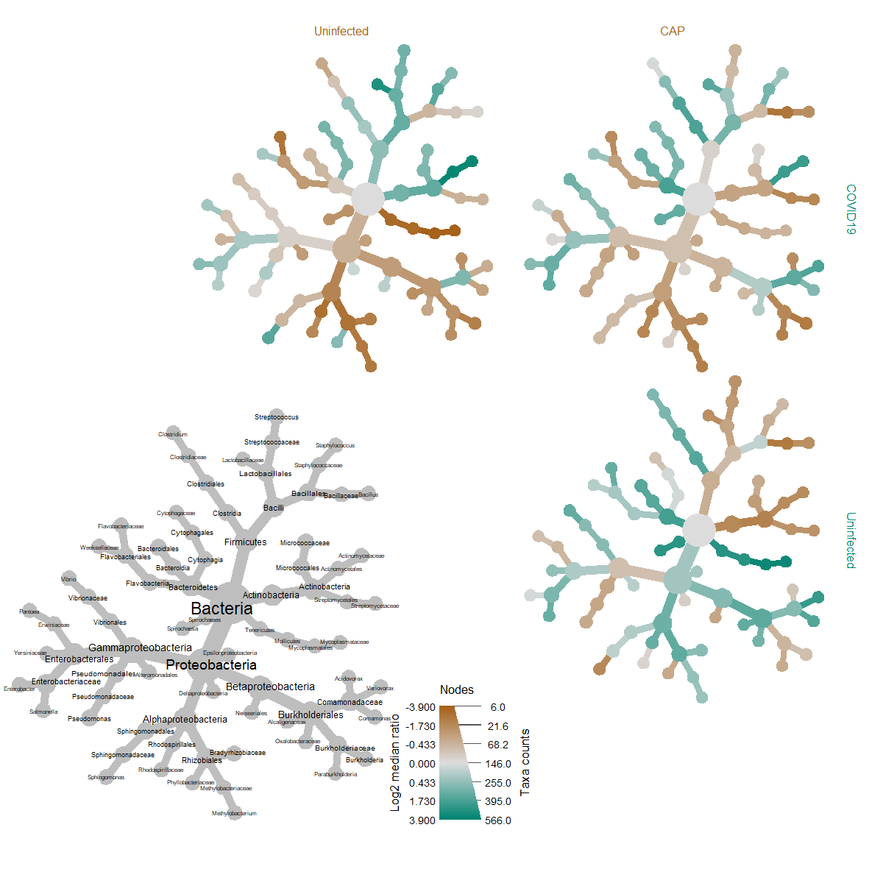

Figure 2. Heat Tree Matrix Visualizing Distinct COVID-19 vs. Uninfected & Viral Pneumonia Taxonomic Profiles. Significant changes were identified in log2 median ration of several species belonging to the genus *Sphingomonas* when compared to both the uninfected (top left) and community acquired pneumonia cohorts (top right).



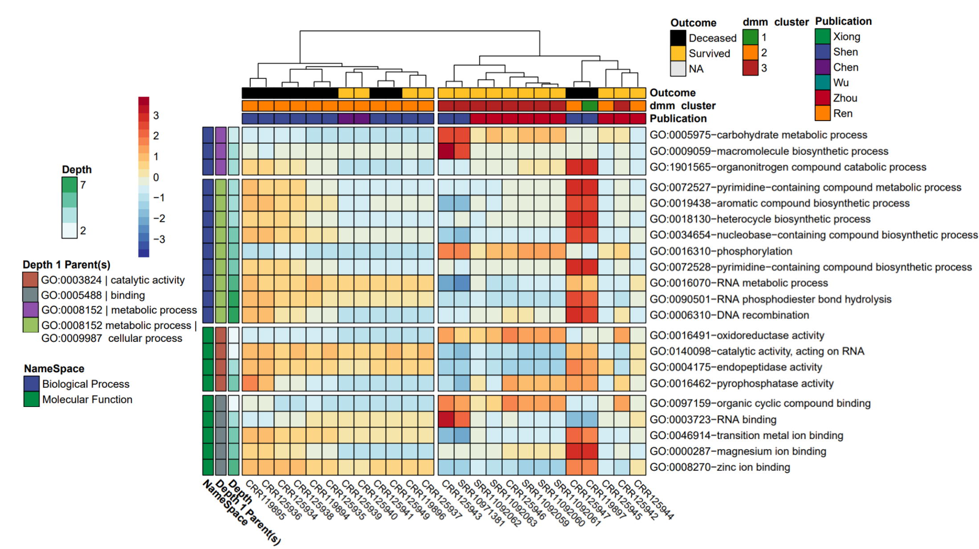

Figure 3. Heatmap of Significantly Different Gene Ontology Terms Associated with COVID-19 Mortality Comparing Deceased (n=10) versus Survived (n=15). Rows are sorted by parental GO terms (depth=1) and columns are clustered by Euclidean distance using ward D2 clustering. Comparisons were conducted using MaAsLin2, controlling for patient ID with Benjamini Hochberg multiple test comparison (q<0.05).

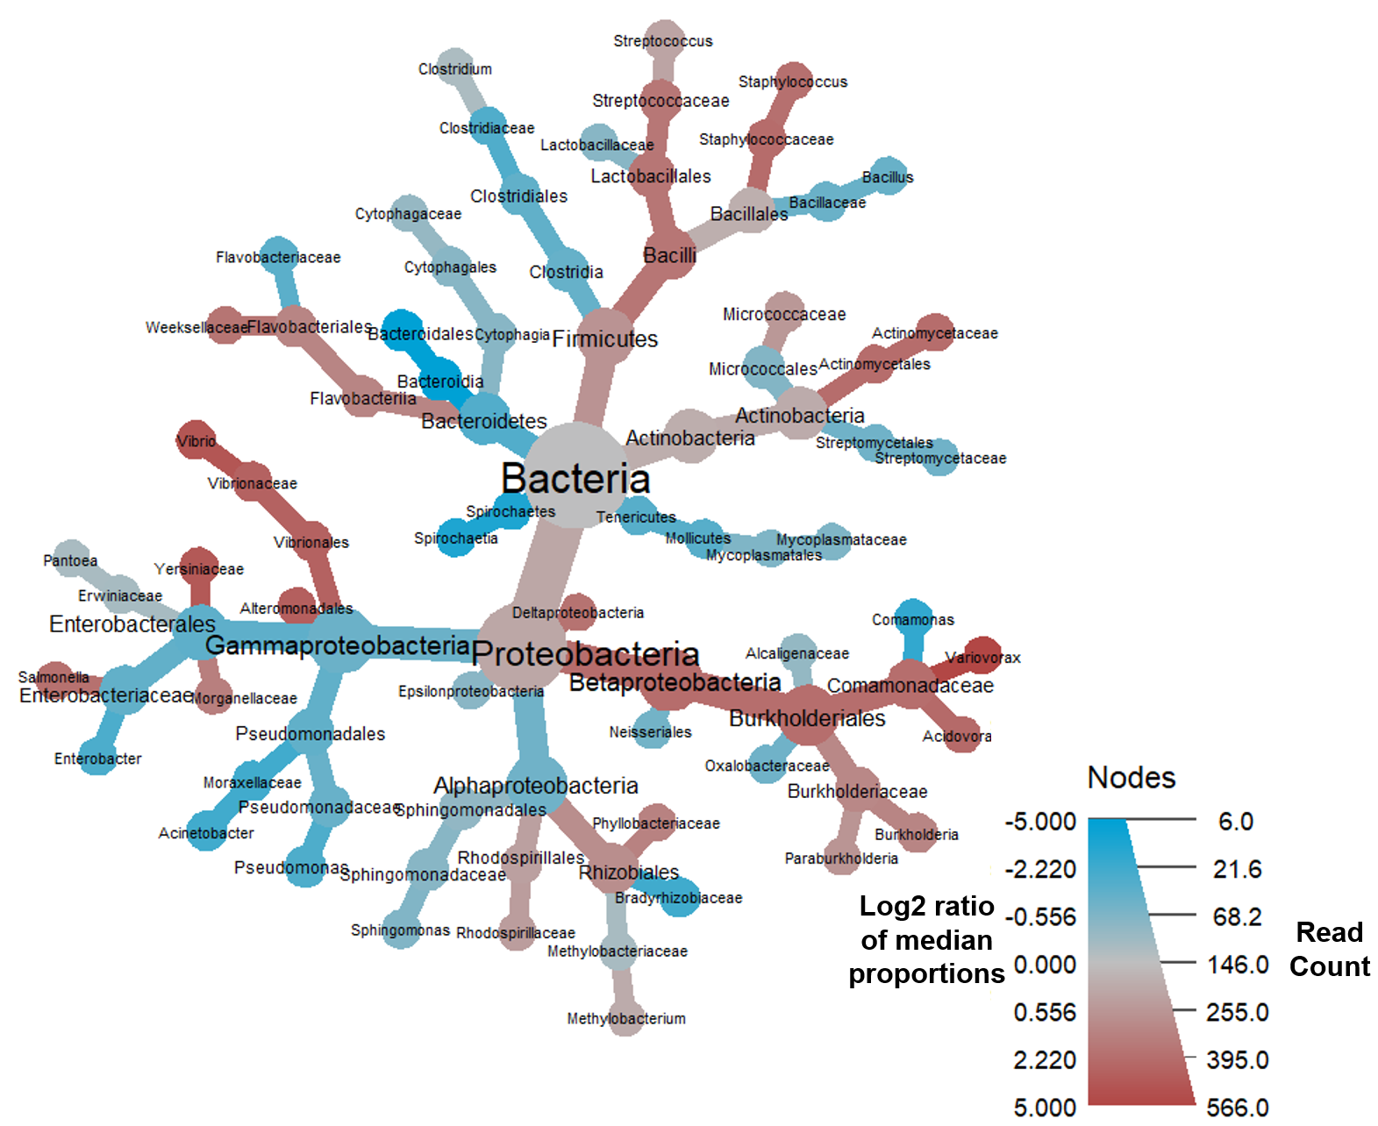

Figure 4. Heat Tree Demonstrating the BALF Metatransciptome Profiles Associated with COVID-19 Mortality. Notable increases were observed in the log2 median ratios in the Family *Comamonadaceae,* genus *Variovorax,* and significant decreases in the log2 median ratios of order *Bacteroidia* and class *Bacteroidales.*